A

REPORT

ON

**ONLINE CODE COMPILER**

SUBMITTED TO

GUJARAT TECHNOLOGICAL UNIVERSITY, AHMEDABAD.

IN PARTIAL FULFILLMENT OF THE REQUIREMENT FOR THE AWARDS OF

DIPLOMA IN COMPUTER ENGINEERING

SUBMITTED BY

**ENROLLMENT NO**  **NAME OF STUDENT**

1) 176620307029 PRATIK B. KANSARA

2) 176620307016 PRANAV P. CHANPARA

3)176620307028 VANDIT D. JOSHI

4)176620307031 RUTVIK M. KATHAROTIA

**GUIDED BY**

Prof. PAYAL M. BODA

Computer Engineering Department

Darshan Institute of Engineering & Technology

For Diploma Studies,

Rajkot.



**2019-2020**

**DEPARTMENT OF COMPUTER ENGINEERING**

**DARSHAN INSTITUTE OF ENGINEERING & TECHNOLOGY**

**FOR DIPLOMA STUDIES**

**RAJKOT-MORBI HIGHWAY, RAJKOT (GUJARAT).**



**DARSHAN**

**INSTITUTE OF ENGINEERING & TECHNOLOGY**

**FOR DIPLOMA STUDIES**

**Certificate**

This is to certify that,

**Mr. PRATIK B. KANSARA** having Enrollment No:**176620307029** has completed **Part-II UDP** Project work for **Semester VI** having title **CODE TRAINER,** in a group of **4** persons under the guidance of the Faculty Guide **Prof. PAYAL M. BODA.**

|  |  |
| --- | --- |
| **Guide** | **Head of Department** |
| Prof. PAYAL M. BODA  Computer Engg. Dept.  Darshan Institute of Engg. & Tech.  For Diploma Studies,  Rajkot. | Prof. CHINTAN N. KANANI  Computer Engg. Dept.  Darshan Institute of Engg. & Tech.  For Diploma Studies,  Rajkot. |

**2019-2020**

**DEPARTMENT OF COMPUTER ENGINEERING**

**DARSHAN INSTITUTE OF ENGINEERING & TECHNOLOGY**

**FOR DIPLOMA STUDIES**

**RAJKOT-MORBI HIGHWAY, RAJKOT (GUJARAT).**



**DARSHAN**

**INSTITUTE OF ENGINEERING & TECHNOLOGY**

**FOR DIPLOMA STUDIES**

**Certificate**

This is to certify that,

**Mr. PRANAV P. CHANPARA** having Enrollment No:**176620307016** has completed **Part-II UDP** Project work for **Semester VI** having title **CODE TRAINER,** in a group of **4** persons under the guidance of the Faculty Guide **Prof. PAYAL M. BODA.**

|  |  |
| --- | --- |
| **Guide** | **Head of Department** |
| Prof. PAYAL M. BODA  Computer Engg. Dept.  Darshan Institute of Engg. & Tech.  For Diploma Studies,  Rajkot. | Prof. CHINTAN N. KANANI  Computer Engg. Dept.  Darshan Institute of Engg. & Tech.  For Diploma Studies,  Rajkot. |

**2019-2020**

**DEPARTMENT OF COMPUTER ENGINEERING**

**DARSHAN INSTITUTE OF ENGINEERING & TECHNOLOGY**

**FOR DIPLOMA STUDIES**

**RAJKOT-MORBI HIGHWAY, RAJKOT (GUJARAT).**



**DARSHAN**

**INSTITUTE OF ENGINEERING & TECHNOLOGY**

**FOR DIPLOMA STUDIES**

**Certificate**

This is to certify that,

**Mr. VANDIT D. JOSHI** having Enrollment No:**176620307028** has completed **Part-II UDP** Project work for **Semester VI** having title **CODE TRAINER,,** in a group of **4** persons under the guidance of the Faculty Guide **Prof. PAYAL M. BODA.**

|  |  |
| --- | --- |
| **Guide** | **Head of Department** |
| Prof. PAYAL M. BODA  Computer Engg. Dept.  Darshan Institute of Engg. & Tech.  For Diploma Studies,  Rajkot. | Prof. CHINTAN N. KANANI  Computer Engg. Dept.  Darshan Institute of Engg. & Tech.  For Diploma Studies,  Rajkot. |

**2019-2020**

**DEPARTMENT OF COMPUTER ENGINEERING**

**DARSHAN INSTITUTE OF ENGINEERING & TECHNOLOGY**

**FOR DIPLOMA STUDIES**

**RAJKOT-MORBI HIGHWAY, RAJKOT (GUJARAT).**



**DARSHAN**

**INSTITUTE OF ENGINEERING & TECHNOLOGY**

**FOR DIPLOMA STUDIES**

**Certificate**

This is to certify that,

**Mr. RUTVIK M. KATHROTIYA** having Enrollment No:**176620307031** has completed  **Part-II UDP** Project work for **Semester VI** having title **CODE TRAINER,** in a group of **4** persons under the guidance of the Faculty Guide **Prof. PAYAL M. BODA.**

|  |  |
| --- | --- |
| **Guide** | **Head of Department** |
| Prof. PAYAL M. BODA  Computer Engg. Dept.  Darshan Institute of Engg. & Tech.  For Diploma Studies,  Rajkot. | Prof. CHINTAN N. KANANI  Computer Engg. Dept.  Darshan Institute of Engg. & Tech.  For Diploma Studies,  Rajkot. |

**2019-2020**

**DEPARTMENT OF COMPUTER ENGINEERING**

**DARSHAN INSTITUTE OF ENGINEERING & TECHNOLOGY**

**FOR DIPLOMA STUDIES**

**RAJKOT-MORBI HIGHWAY, RAJKOT (GUJARAT).**



**DARSHAN**

**INSTITUTE OF ENGINEERING & TECHNOLOGY**

**FOR DIPLOMA STUDIES**

**EXAMINER’S CERTIFICATE OF APPROVAL**

This is to certify that draft report entitled **CODE TRAINER,** submitted by **PRATIK B. KANSARA** **(176620307029)**, **PRANAV P. CHANPARA** **(176620307016), VANDIT D. JOSHI (176620307028), RUTVIK M. KATHAROTIA (176620307031)** in partial fulfillment for the award of the diploma in **Computer** **Engineering** of the Gujarat Technological University-Ahmedabad is hereby approved.

Internal Examiners External Examiners

**2019-2020**

**DEPARTMENT OF COMPUTER ENGINEERING DARSHAN INSTITUTE OF ENGINEERING & TECHNOLOGY**

**FOR DIPLOMA STUDIES**

**RAJKOT-MORBI HIGHWAY, RAJKOT (GUJARAT).**

**ACKNOWLEDGEMENT**

A successful project can never be prepared by single effort, but it also demands the help and guardianship of some conversant person who helps in the undersigned actively into the completion of successful project.

With great pleasure we express our gratitude to our guide Mrs. PAYAL M. BODA and Prof. CHINTAN N. KANANI without their help this would not have been completed.

They have given Their precious suggestions and constative guidance that help us to complete project

**INDEX**

|  |  |  |  |
| --- | --- | --- | --- |
| **Chapter No.** | **Sub Chapter**  **No.** | **Content** | **Page No.** |
|  |  | **Abstract** |  |
| 1 |  | **Problem Summary**………………………………………………... | 1 |
|  | 1.1 | Problem Identification ……………………………………………. | 1 |
|  | 1.2 | Problem Solution………………………………………………….. | 1 |
| 2 |  | **Planning**……………………………………………………………. | 2 |
|  | 2.1 | Model Description………………………………………………….. | 2 |
|  | 2.2 | Risk Management…………………………………………………... | 5 |
| 3 |  | **Detail Description**…………………………………………………. | 6 |
| 4 |  | **Diagrams**…………………………………………………………… | 8 |
|  | 4.1 | Class Diagram………………………………………………………. | 8 |
|  | 4.2 | Sequence Diagram………………………………………………….. | 9 |
|  | 4.3 | Collaboration Diagram……………………………………………... | 10 |
|  | 4.4 | State Diagram………………………………………………………. | 11 |
|  | 4.5 | Activity Diagram…………………………………………………… | 12 |
|  | 4.6 | Use Case Diagram………………………………………………….. | 13 |
|  | 4.7 | Data Flow Diagram (Level 0)……………………………………… | 14 |
|  |  | Data Flow Diagram (Level 1)……………………………………… | 15 |
| 5 |  | **Data Dictionary**…………………………………………………… | 17 |
|  | 5.1 | E-R Diagram……………………………………………………….. | 19 |
| 6 |  | **Screen Shots**……………………………………………………….. | 20 |
| 7 |  | **Conclusion**…………………………………………………………. | 39 |
| 8 |  | **Future Enhancement**……………………………………………. | 40 |

**ABSTRACT**

In present scenario usage of technology is widely increased mainly usage of internet had reached to every home.For eg. if you have to compile java program then we need JDK(Java Devlopment Kit) installed in your system. It is time taking process. But if you use our website no need to install JDK to your system. Our website allows you to compile source code and execute it online in different languages. Our website will provide online debugging and also allow to run the code in threee different languages. Users need to write code in editor and press "Run" button to compile and execute it. User also solve problem to increase logic by clicking problem solving.

**1. PROBLEM SUMMARY**

**1.1 Problem Identification**

If a user has to run and execute the source code of the program, he has to install all the necessary software in the system they will consume more required space in the device. And this is time taking process. Use can not do coding of different languages using one software.

**1.2 Problem Solution**

By using our website the space required to install software will be reduced on your device. And user can perform coding of different programming languages like c,c++ and java at the same place..

**2. PLANNING**

**2.1 Model Description**

Feasibility study

Requirement analysis and specificationspssssssspespecification

Design

Maintenance

Integration and system testing

Coding and unit testing

**Fig. Iterative Waterfall Model**

* In our project we are using iterative waterfall model.
* It is not possible to strictly follow the classical waterfall model.
* Making necessary changes to the classical waterfall model so that it becomes applicable to practical software development projects.
* The main change to the classical waterfall model is in the form of providing feedback paths from every phase to its preceding phases as shown in figure.
* The feedback paths allow for correction of the errors committed during a phase as and when these are detected in a later phases.

For example if during testing a design error is identified then the feedback path allows the design to be reworked and the changes to be reflected in the design document

* There is no feedback path to the feasibility stage. This means that the feasibility study errors cannot be corrected.

**Requirements analysis and specification**

* The aim of the requirements analysis and specification phase is to understand the exact requirements of the customer and to document them properly. This phase consists of two distinct activities, namely
* Requirements gathering and analysis, and
* Requirements specification
* The goal of the requirements gathering activity is to collect all relevant information from the customer regarding the product to be developed. This is done to clearly understand the customer requirements so that incompleteness and inconsistencies are removed.
* The requirements analysis activity is begun by collecting all relevant data regarding the product to be developed from the users of the product and from the customer through interviews and discussions.
* During SRS activity, the user requirements are systematically organized into a Software Requirements Specification (SRS) document.

**Design**

* During the design phase the software architecture is derived from the SRS document. Two distinctly different approaches are available.
* Traditional design consists of two different activities; first a structured analysis of the requirements specification is carried out where the detailed structure of the problem is examined. During structured design, the results of structured analysis are transformed into the software design.

**Coding and unit testing (Implementation)**

* The purpose of the coding and unit testing phase of software development is to translate the software design into source code. Each component of the design is implemented as a program module. The end-product of this phase is a set of program modules that have been individually tested.
* Each module is unit tested for determine the correct working of all the individual modules.

**Integration and system testing**

* Integration of different modules is done once they have been coded and unit tested. During the integration and system testing phase, the modules are integrated in a planned manner.
* Finally, when all the modules have been successfully integrated and tested, system testing is carried out. The goal of system testing is to ensure that the developed system conforms to its requirements laid out in the SRS document. System testing usually consists of three different kinds of testing activities.
* α – testing: It is the system testing performed by the development team.
* β – Testing: It is the system testing performed by a friendly set of customers.
* Acceptance testing: It is the system testing performed by the customer himself after the product delivery to determine whether to accept or reject the delivered product.

**Maintenance**

* Maintenance involves performing any one or more of the following three kinds of activities:
* Correcting errors that were not discovered during the product development phase. This is called corrective maintenance.
* Improving the implementation of the system, and enhancing the functionalities of the system according to the customer’s requirements. This is called perfective maintenance.
* Porting the software to work in a new environment. For example, porting may be required to get the software to work on a new computer platform or with a new operating system. This is called adaptive maintenance.

**2.2 RISK MANAGEMENT**

**Risk Management**

* The aim of risk management is to reducing the impact of all kind of risks that might affect a project. Risk management consists of three essential activities: risk identification, risk assessment, and risk containment.

**Risk Identification**

* A software project can be affected by a large variety of risks. In order to be able to systematically identify the important risks which might affect a software project, it is necessary to categorize risks into different classes.
* The project manager can then examine which risks from each class are relevant to the project. There are three main categories of risks which can affect a software project:

**Project Risks**

* Project risks concern varies forms of budgetary, schedule, personnel, resource, and customer-related problems. An important project risk is schedule. It is very difficult to monitor and control a software project.
* It is very difficult to control something which cannot be seen.
* The invisibility of the product being developed is an important reason for many software projects failure.
* So in our project we are trying to resolve this kind of project risk which is also known as schedule risk.

**Technical Risks**

* Technical risks concern design, implementation, interfacing, testing, and maintenance problems.
* Technical risks also include ambiguous specification, incomplete specification, changing specification, technical uncertainty. Most technical risks occur due to the team member’s insufficient knowledge about the project.
* So in order to prevent this risk, we have done appropriate project analysis before starting our project.

**3. DETAIL DESCRIPTION**

**Admin-**

The Admin can register and add task and its various input and output.Admin can also

See user that register to website.

* **a_ID**: Id of Admin
* **admin_name:** Name of admin
* **admin_pass:** Password of admin

**Tasks-**

The various tasks added by admin are store here.Admin can add , delete , update tasks as per needed.

* **t_ID:** ID of task
* **t_name:** Name of task
* **t_description:** Description of task
* **t_noOfTestcase:**How many testcase to be added
* **t_noOfInput:** How many input in one testcase
* **t_noOfOutput:** How many output in one testcase
* **ct_language:** Language of task

**InputOutput-**

Various input and output added by admin are stored here. It contain inputs and appropriate output.

* **io_ID**: Id of io
* **input**: For input
* **output**: For output
* **t_ID**: Id of task

**Users-**

The all detils of user are stored here like id,username,password,etc.Admin can see user last login , user is active as well as user name.Admin can delete user if needed.

* **u_ID:** Id of user
* **user_name:** Name of user
* **user_pass:** Password of user
* **user_email:**Email of user
* **user_last_login:**User last login
* **user_joined:**user Joined date
* **is_active:**activation of user inform of (0) for deactivate and (1) for activate

**CompletedTasks-**

It stores task completed by user. If user satisfy testcase entered by admin then task is completed and stored.Admin can see Completed tasks done by user.

* **ID:** Id of Completed tasks
* **u_ID:** Id of user
* **t_ID:** Id of task

**4.1 CLASS DIAGRAM**

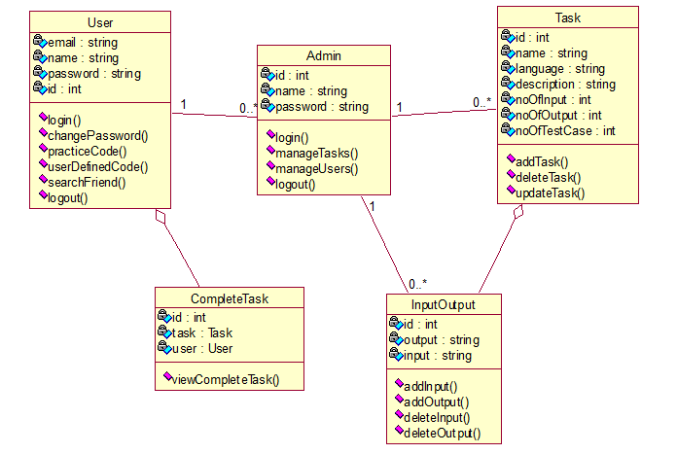

**Fig.4.1 Class Diagram for Code Trainer**

**4.2 SEQUENCE**  **DIAGRAM**



**Fig.4.2 Sequence Diagram for Code Trainer**

**4.3 COLLABORATION DIAGRAM**

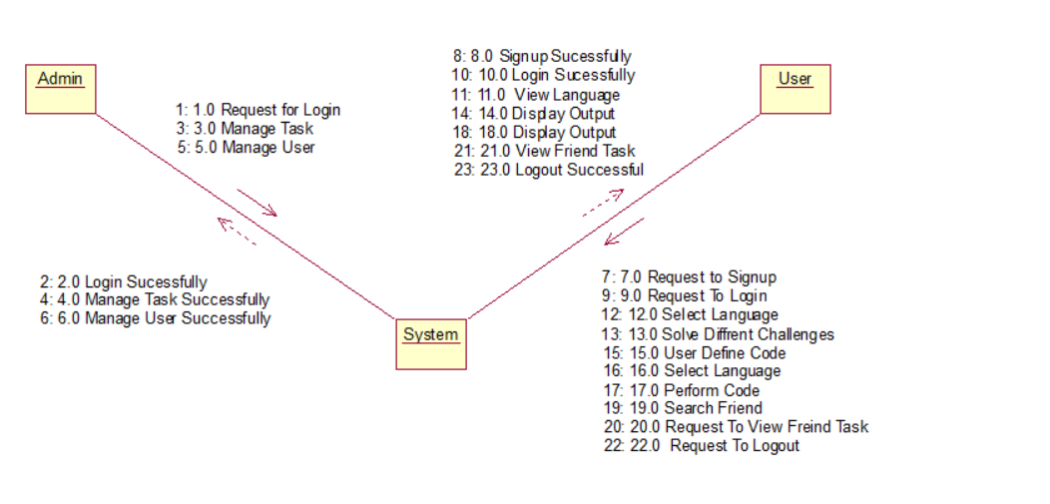

**Fig.4.3 Collaboration Diagram for Code Trainer**

**4.4 STATE DIAGRAM**

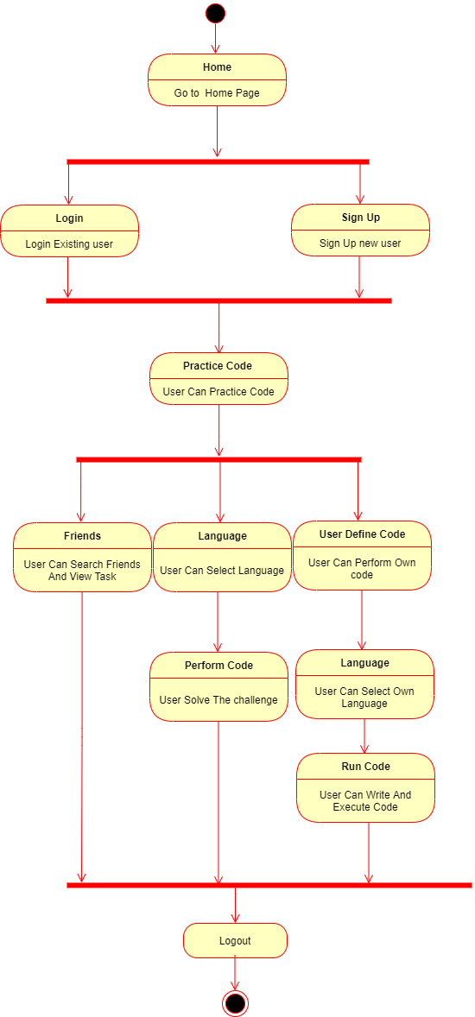

**Fig.4.4 State Diagram for Code Trainer**

**4.5 ACTIVITY DIAGRAM**

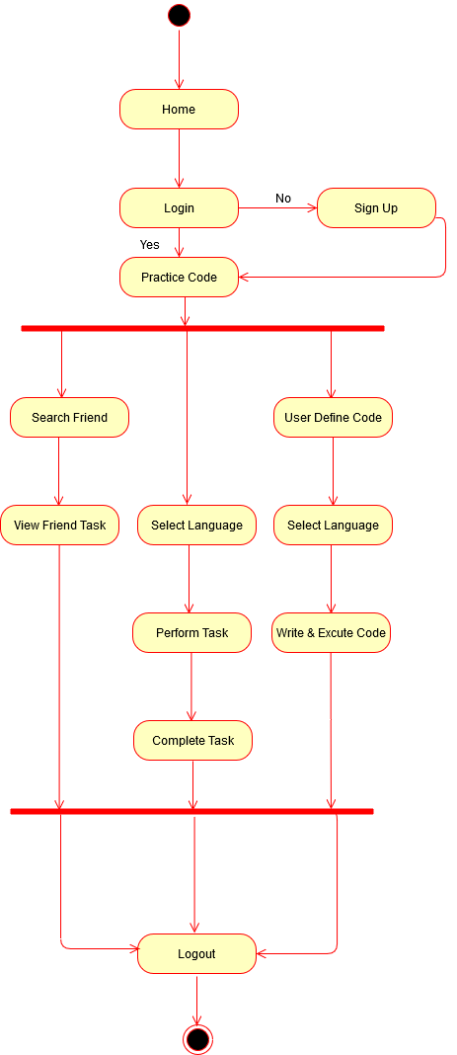

**Fig.4.5 Activity Diagram for Code Trainer**

**4.6 USE CASE DIAGRAM**

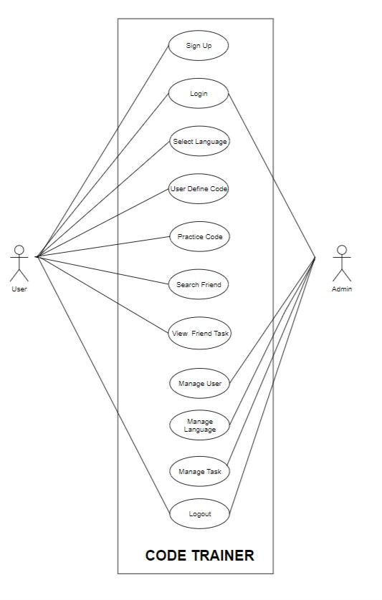

**Fig.4.6 Use case Diagram for Code Trainer**

**4.7 DATA FLOW DIAGRAM**

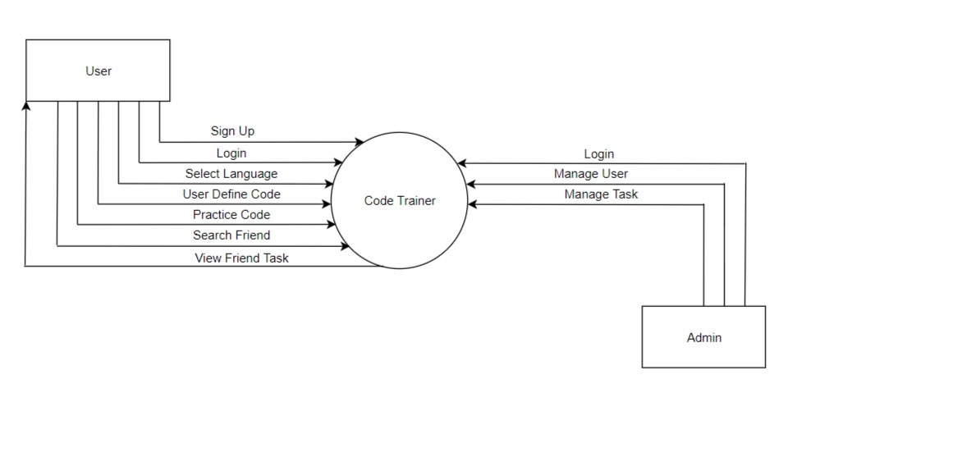

**Fig.4.7.1 Data Flow Diagram for Code Trainer (Level 0)**

**Data Flow Diagram For Code Trainer Admin (Level 1)**

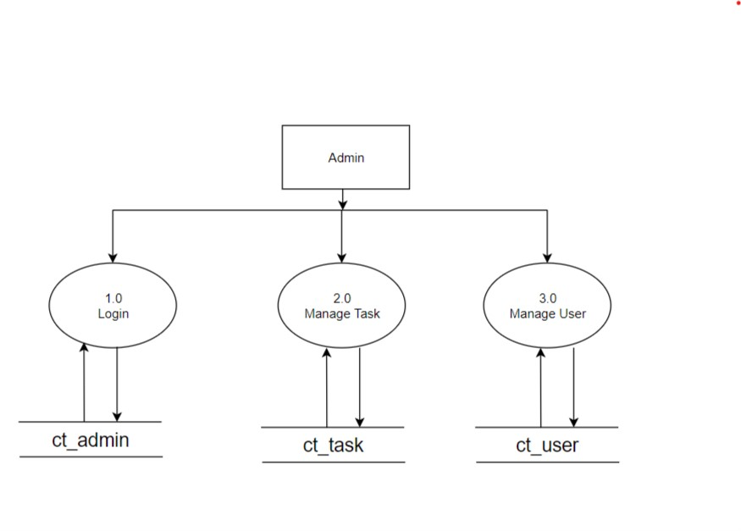

**Fig.4.7.2 Data Flow Diagram for Admin (Level 1)**

**Data Flow Diagram For Code Trainer User (Level 1)**

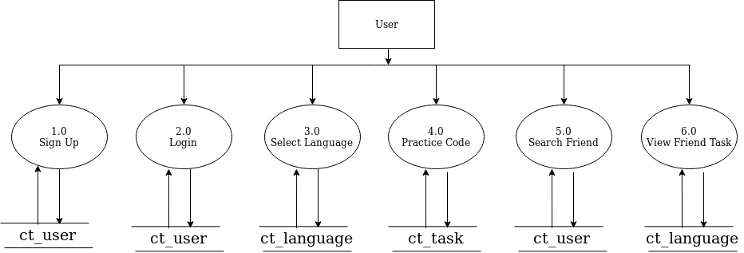

**Fig.4.7.2 Data Flow Diagram for User (Level 1)**

**5. DATA DICTIONARY**

5.1 DATABASE TABLE

|  |  |  |  |  |  |
| --- | --- | --- | --- | --- | --- |
| **ct_user** | | | | | |
| **Field name** | **Data type** | **Size** | **Constraint** | **Reference** | **Description** |
| u_ID | int | 20 | Primary Key | - | To get user Id |
| user_name | varchar | 60 | NOT NULL | - | To get user name |
| user_pass | varchar | 255 | NOT NULL | - | To get user password |
| user_email | varchar | 100 | NOT NULL | - | To get user email |
| user_last_login | datetime | - | NOT NULL | - | Time to get user lastlogin |
| user_Joined | datetime | - | NOT NULL | - | User joined time |
| Is_active | boolean | - | NOT NULL | - | For user activation check |

|  |  |  |  |  |  |
| --- | --- | --- | --- | --- | --- |
| **ct_admin** | | | | | |
| **Field Name** | **Data type** | **Size** | **Constraint** | **Reference** | **Description** |
| a_ID | int | 20 | Primary key | - | For admin id |
| admin_name | varchar | 100 | NOT NULL | - | For admin name |
| Admin_pass | varchar | 100 | NOT NULL | - | For admin password |

|  |  |  |  |  |  |
| --- | --- | --- | --- | --- | --- |
| **ct_tasks** | | | | | |
| **Field Name** | **Data Type** | **Size** | **Constraint** | **Reference** | **Description** |
| t_ID | int | 20 | Primary Key | - | Tssk Id |
| t_name | Varchar | 100 | NOT NULL | - | Taskname |
| t_description | Varchar | 100 | NOT NULL | - | Task description |

|  |  |  |  |  |  |
| --- | --- | --- | --- | --- | --- |
| ct_**io** | | | | | |
| **Field Name** | **Data type** | **Size** | **Constraint** | **Reference** | **Description** |
| io_ID | int | 20 | Primary Key | - | Contain comment ID |
| input | Varchar | 500 | NOT NULL |  | For input |
| output | Varchar | 500 | NOT NULL | - | For output |
| t_ID | int | 50 | NOT NULL | - | For taskId |

|  |  |  |  |  |  |
| --- | --- | --- | --- | --- | --- |
| **ct_completedtasks** | | | | | |
| **Field Name** | **Data Type** | **Size** | **Constraint** | **Reference** | **Description** |
| ID | int | 20 | Primary Key | - | For completed task id |
| u_ID | int | 20 | NOT NULL | - | For user id |
| t_ID | int | 20 | NOT NULL | - | For task id |

**5.1 E-R DIAGRAM**

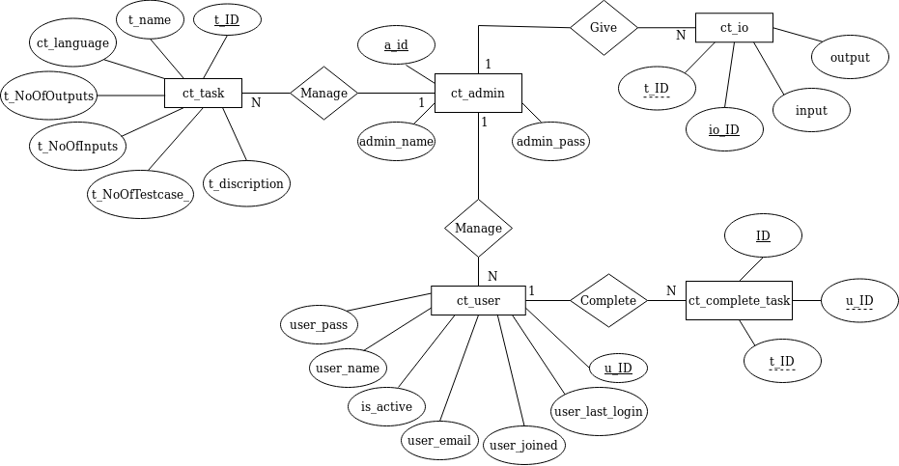

**6. SCREENSHOTS**

**6.1 Welcome Page**

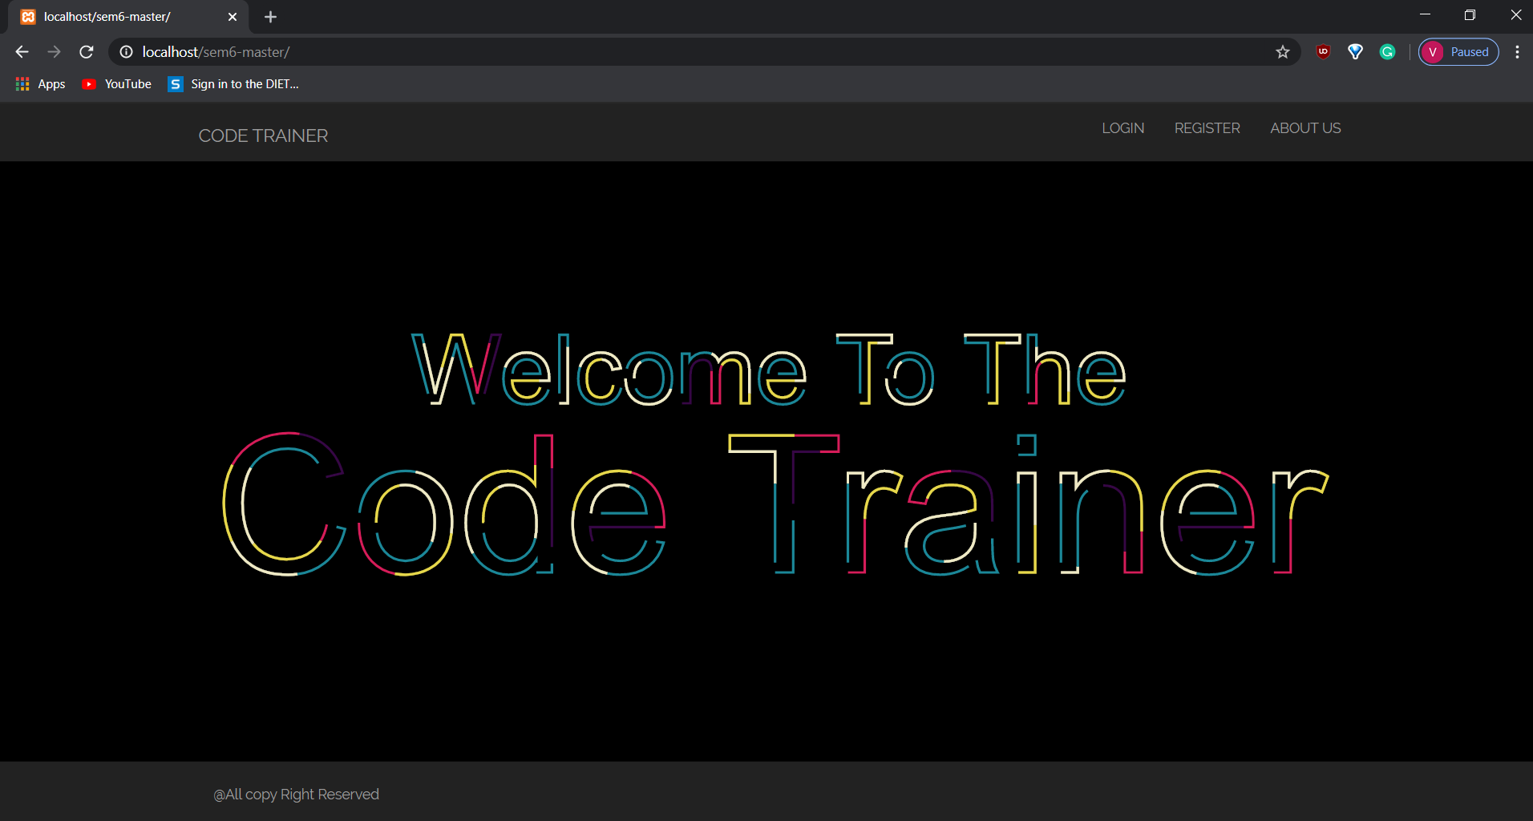

* It is an welcome page of website.
* It appears before the starting of website.

**6.2 Login Page**

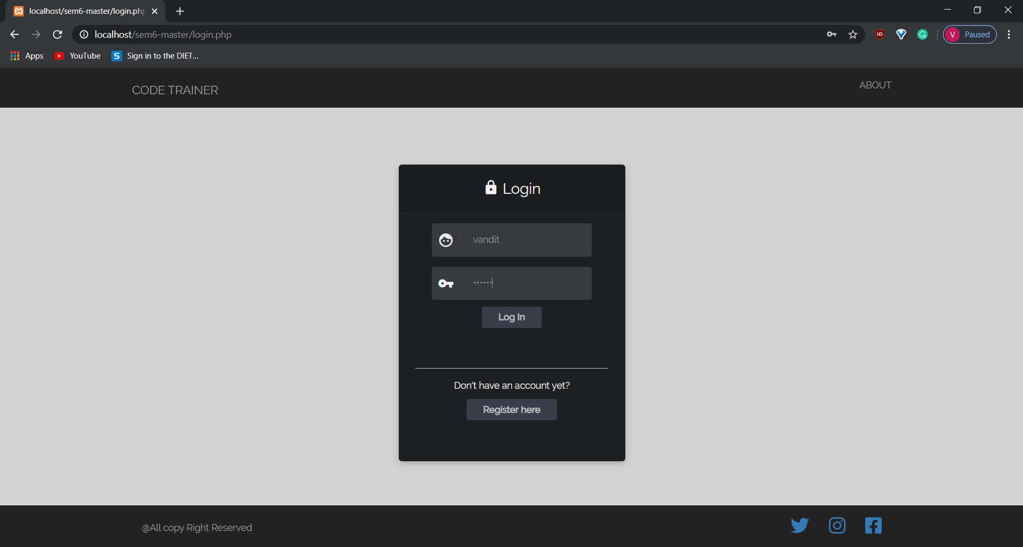

* These page displays the login process.
* User has to login their account in this page for performing further operation.

**6.3 Register Page**

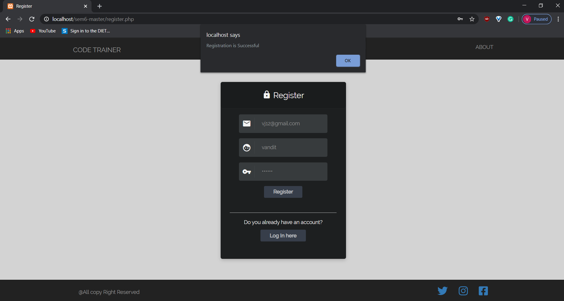

* These page displays the register process.
* New users have to register their details in this page.
* User can register by filling above details.

**6.4 Home Page**

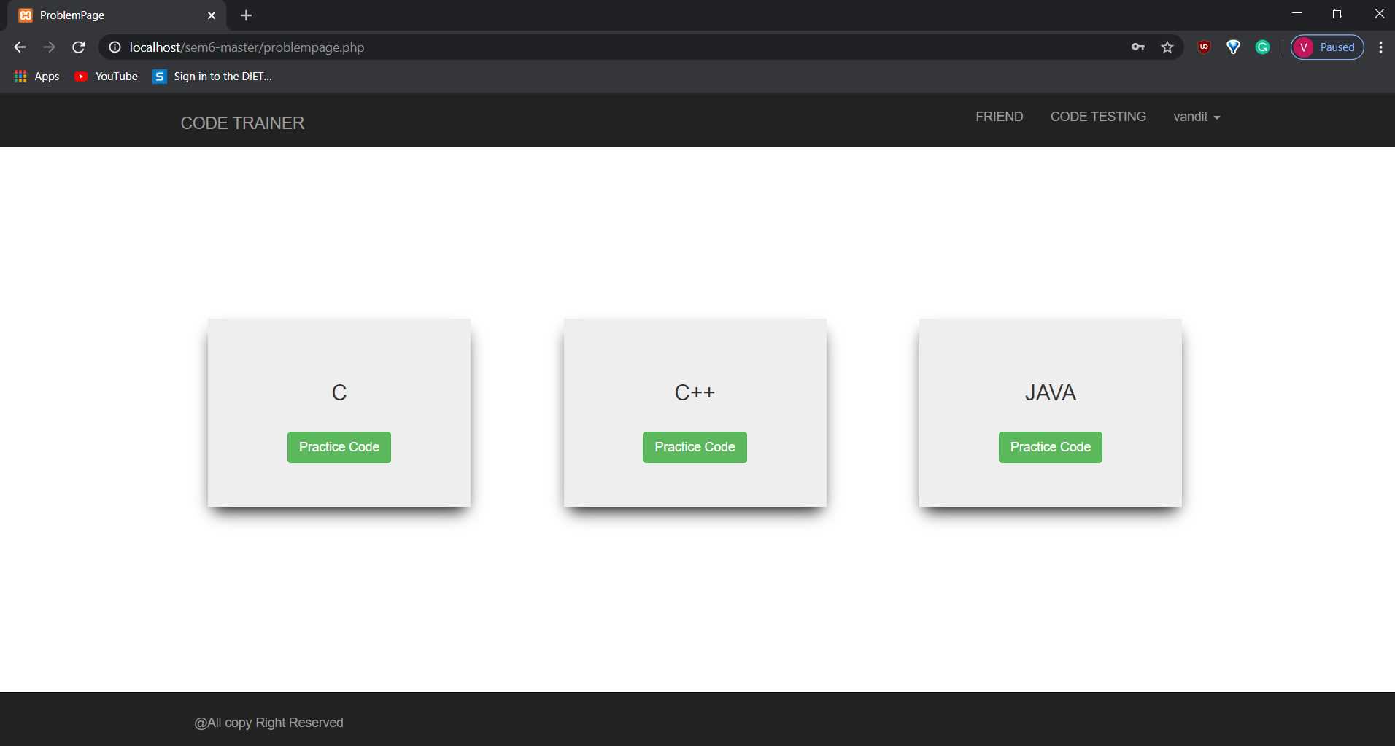

* These page displays the three different programming languages.
* User has to select any one for performing further programming tasks.

**6.5 Code Testing Page**

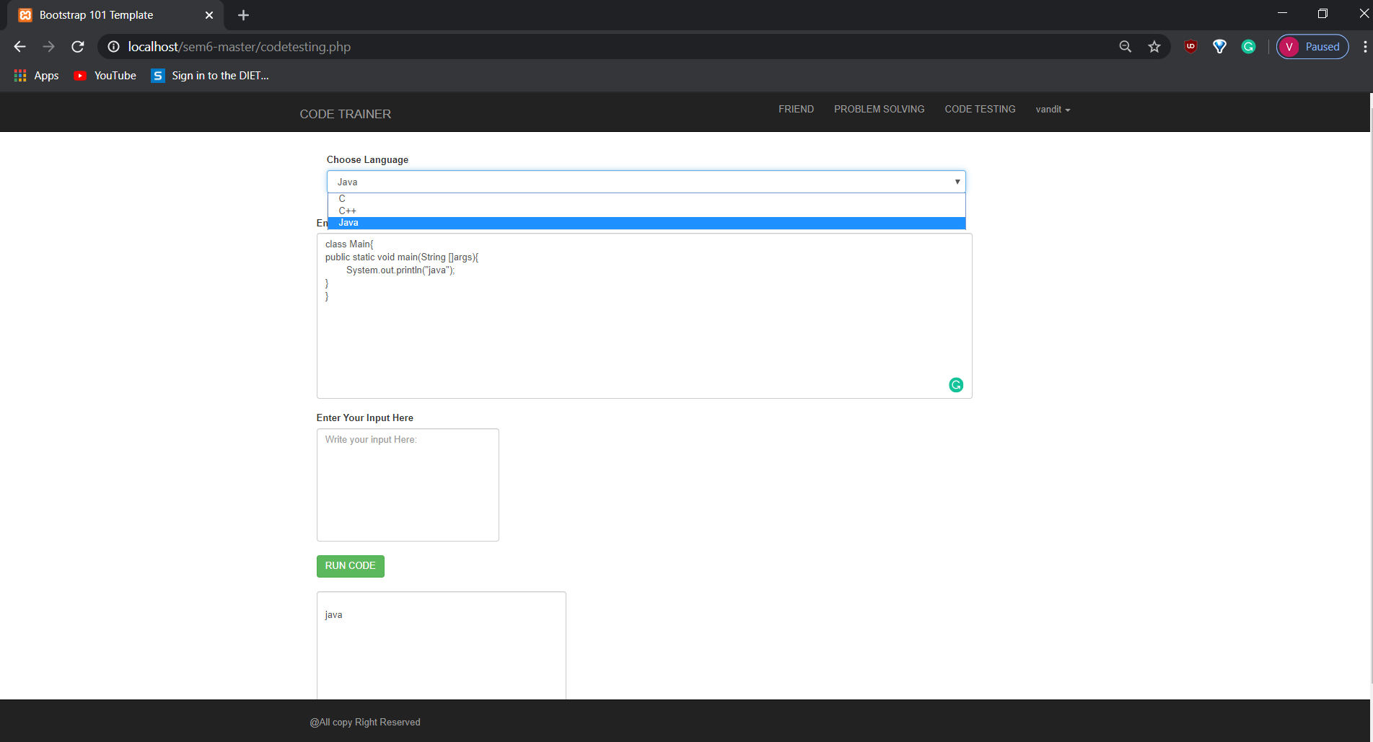

* In this page user has to write code by selecting any one programming language from given options.
* After the code is performed user has to run it by clicking on given green button.
* The output of program will be displayed after clicking on green run code button.

**6.6 Problem Solving**

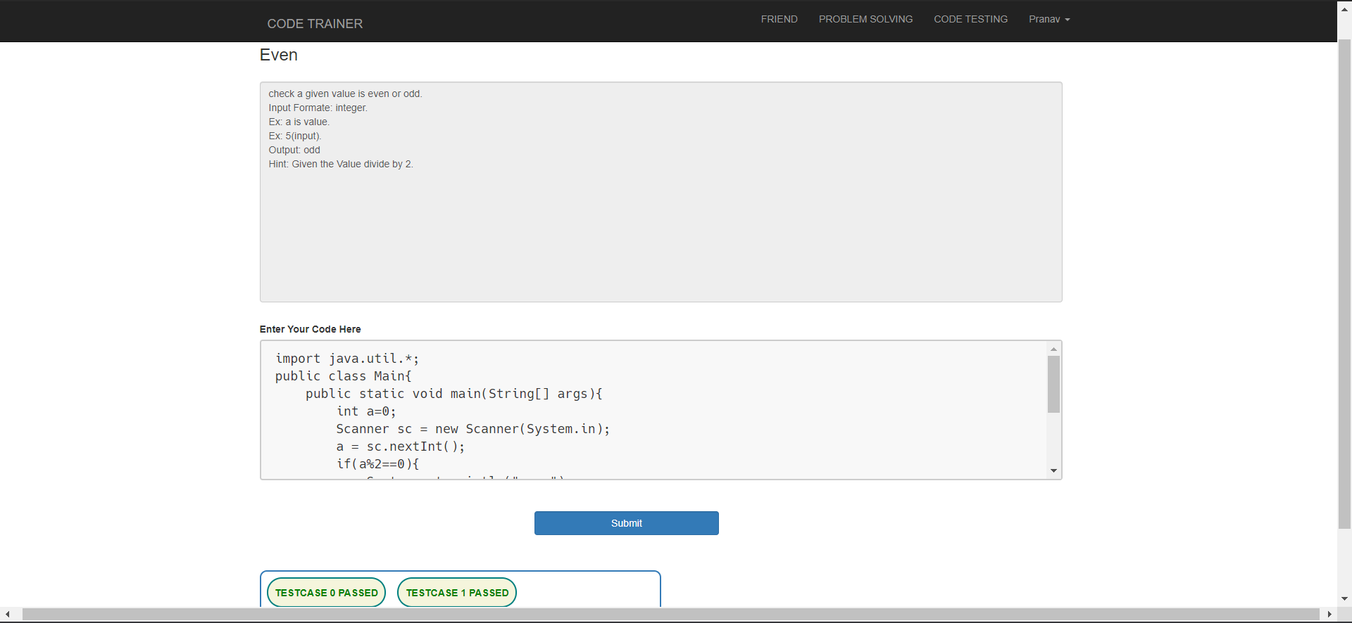

* Problem solving page displays about solving the errors in program performed.
* User can improve their logic level in this page.

**6.7 Search Friend**

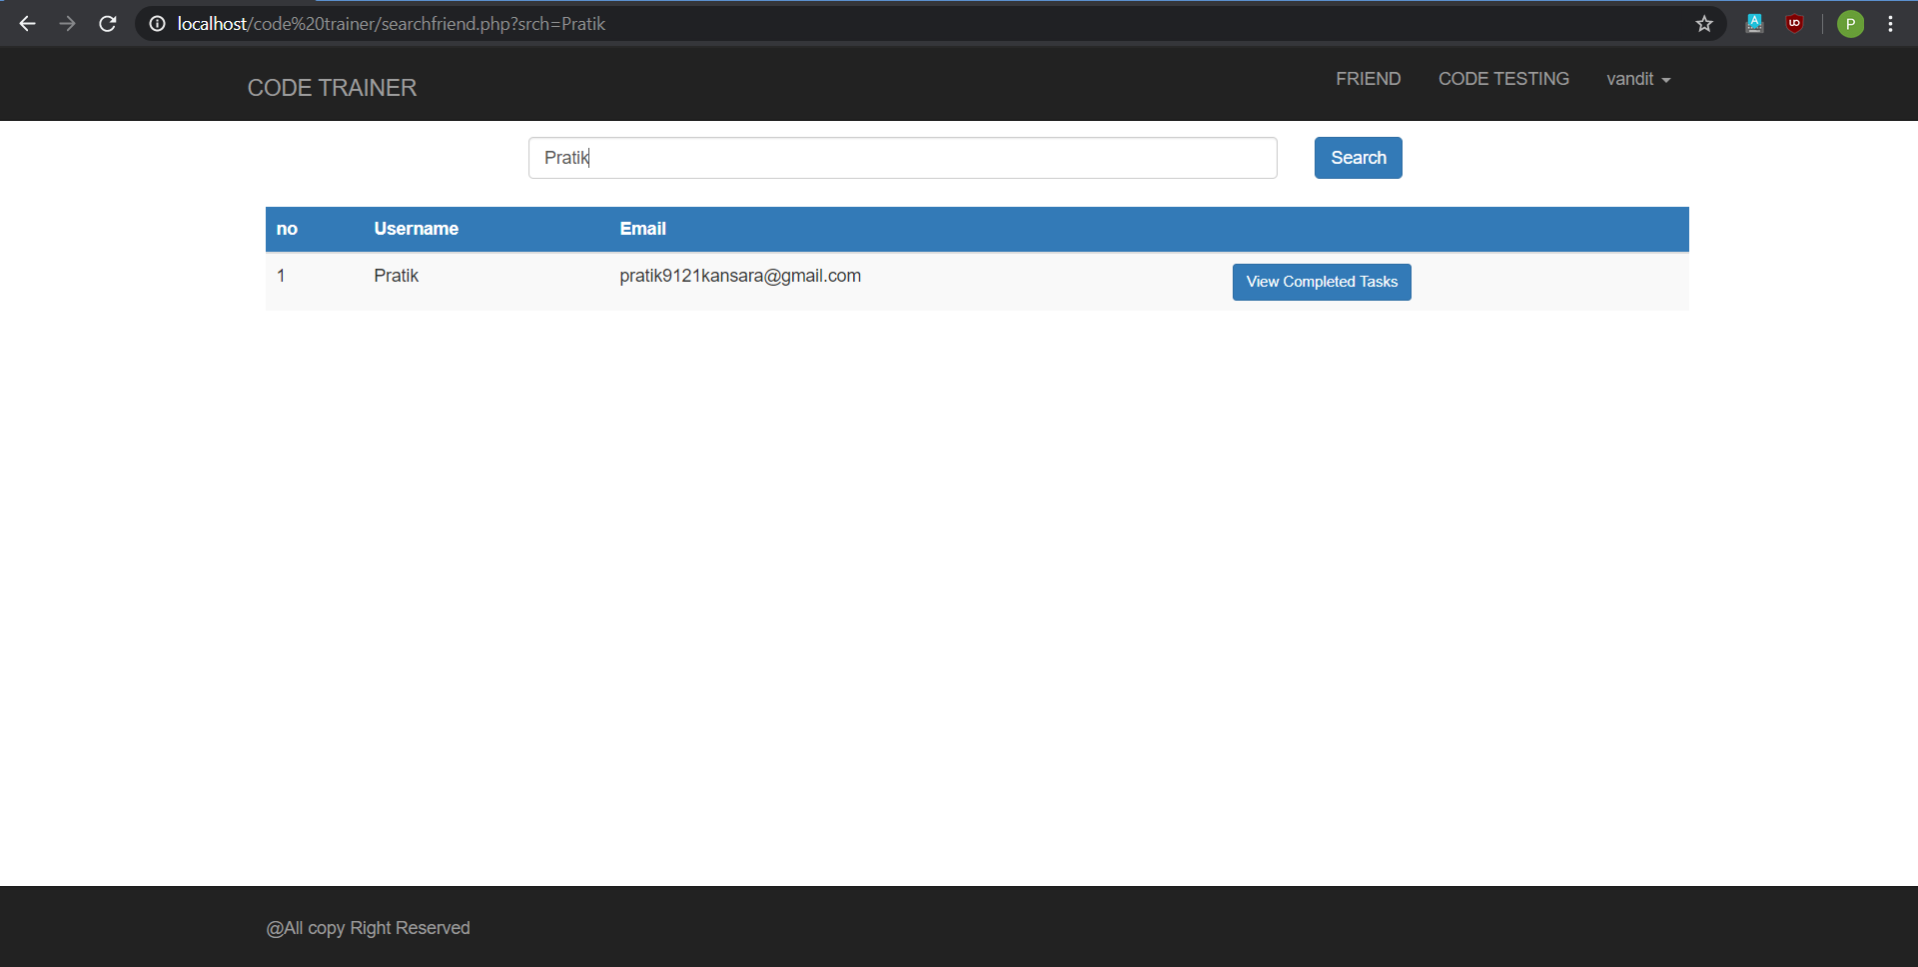

**Fig:-1.1**

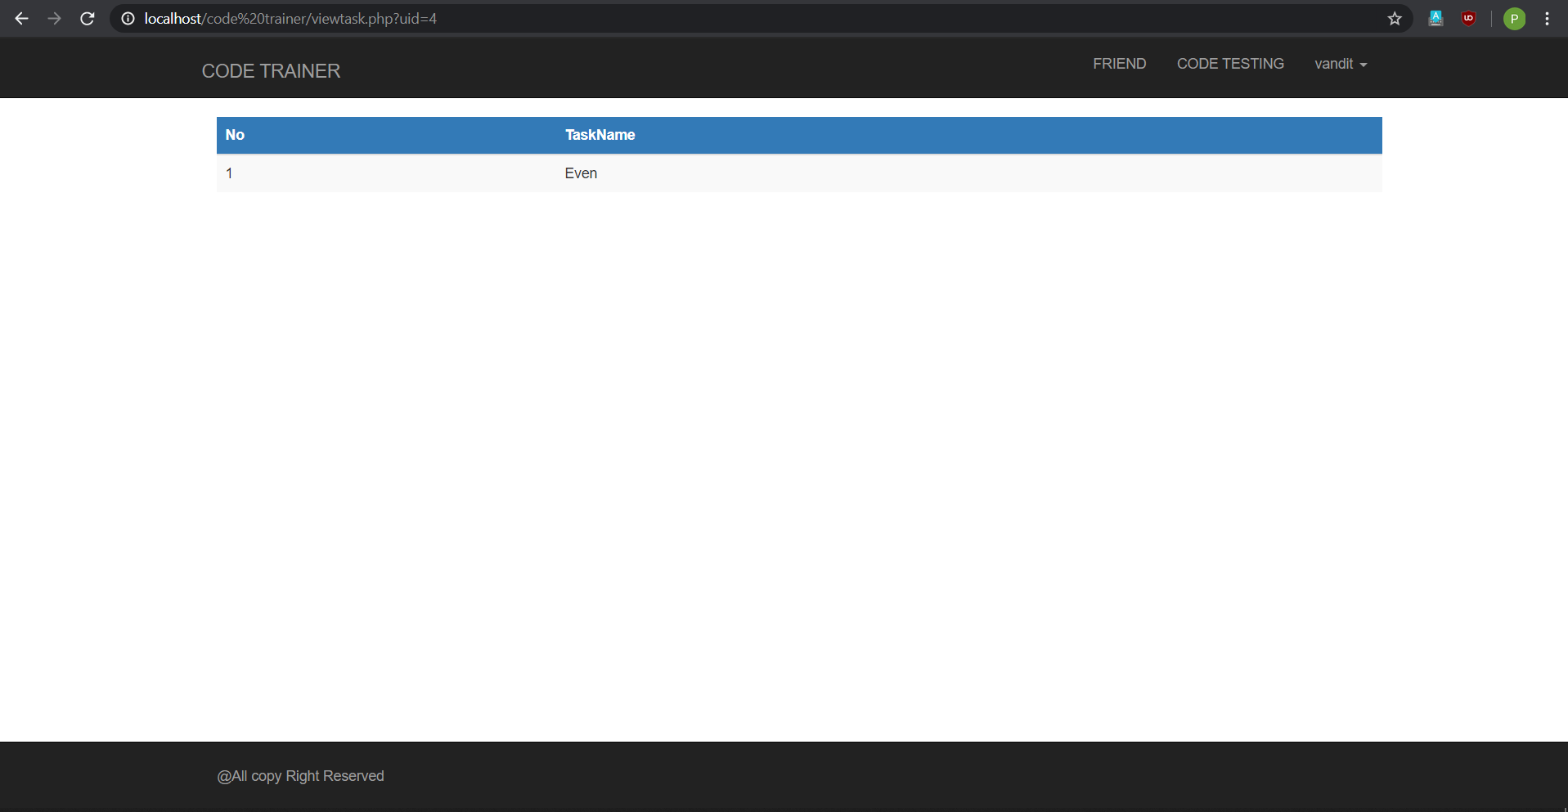

**Fig:-1.2**

* In this page user can search his friend account for getting programs.
* By this user can identify the mistakes or any other codes performed by his friend..

**6.8 Password Change Page for Client**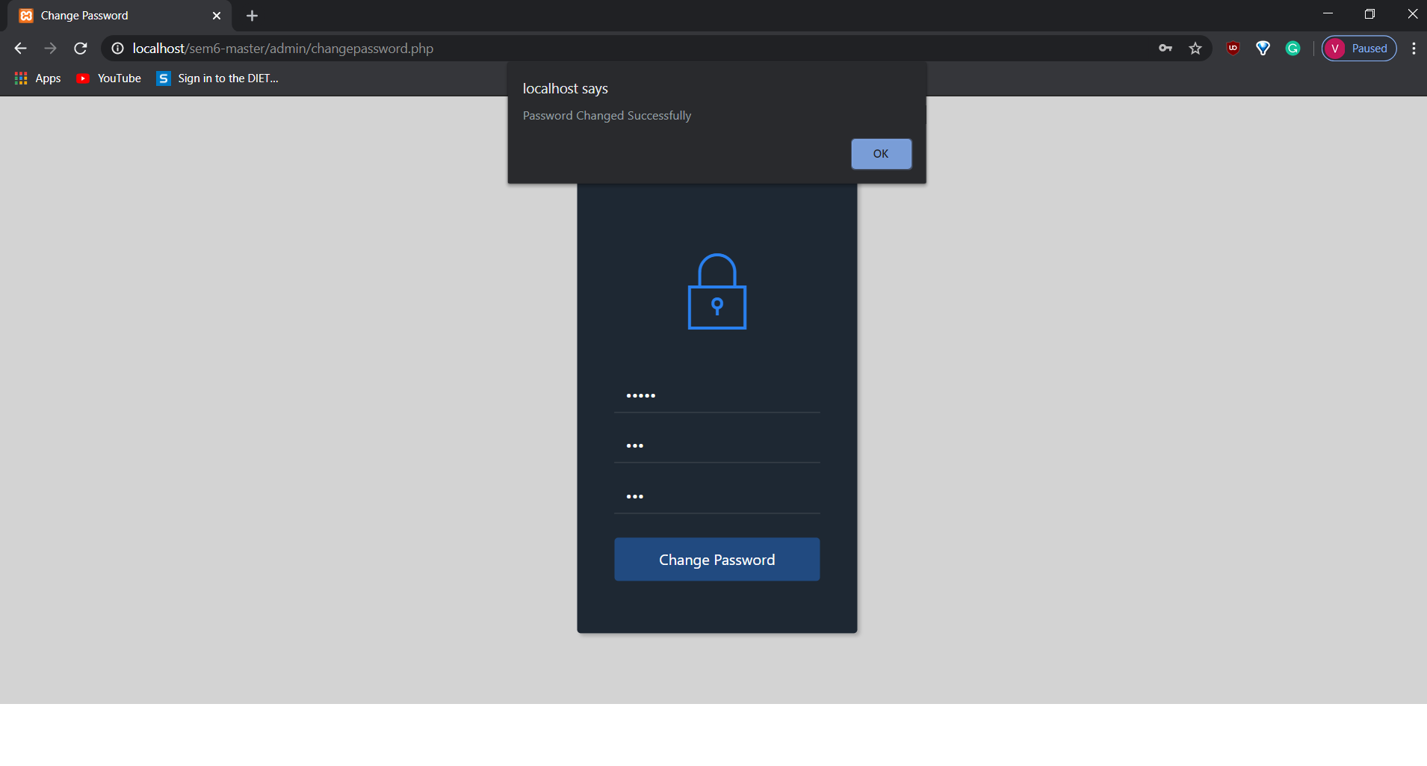

**6.6 Manage Tasks**

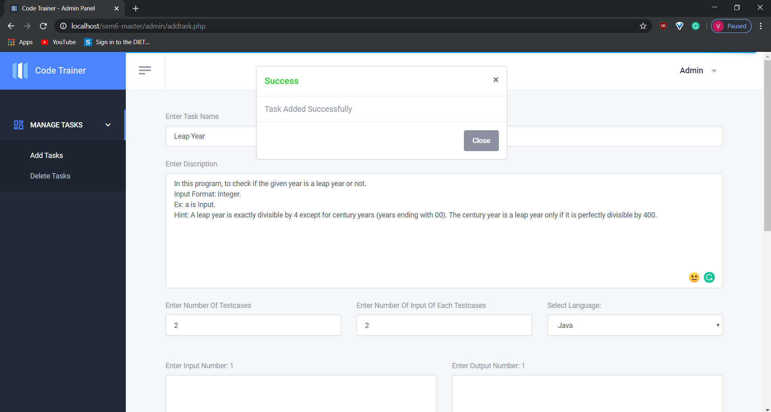

**Fig:-1.1**

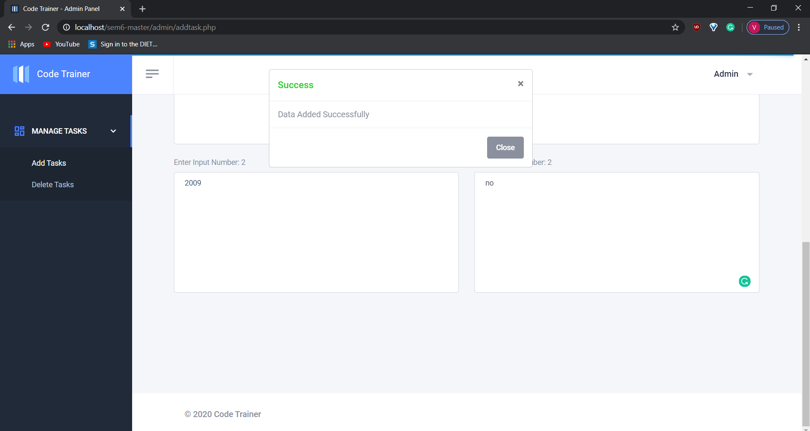

**Fig:-1.2**

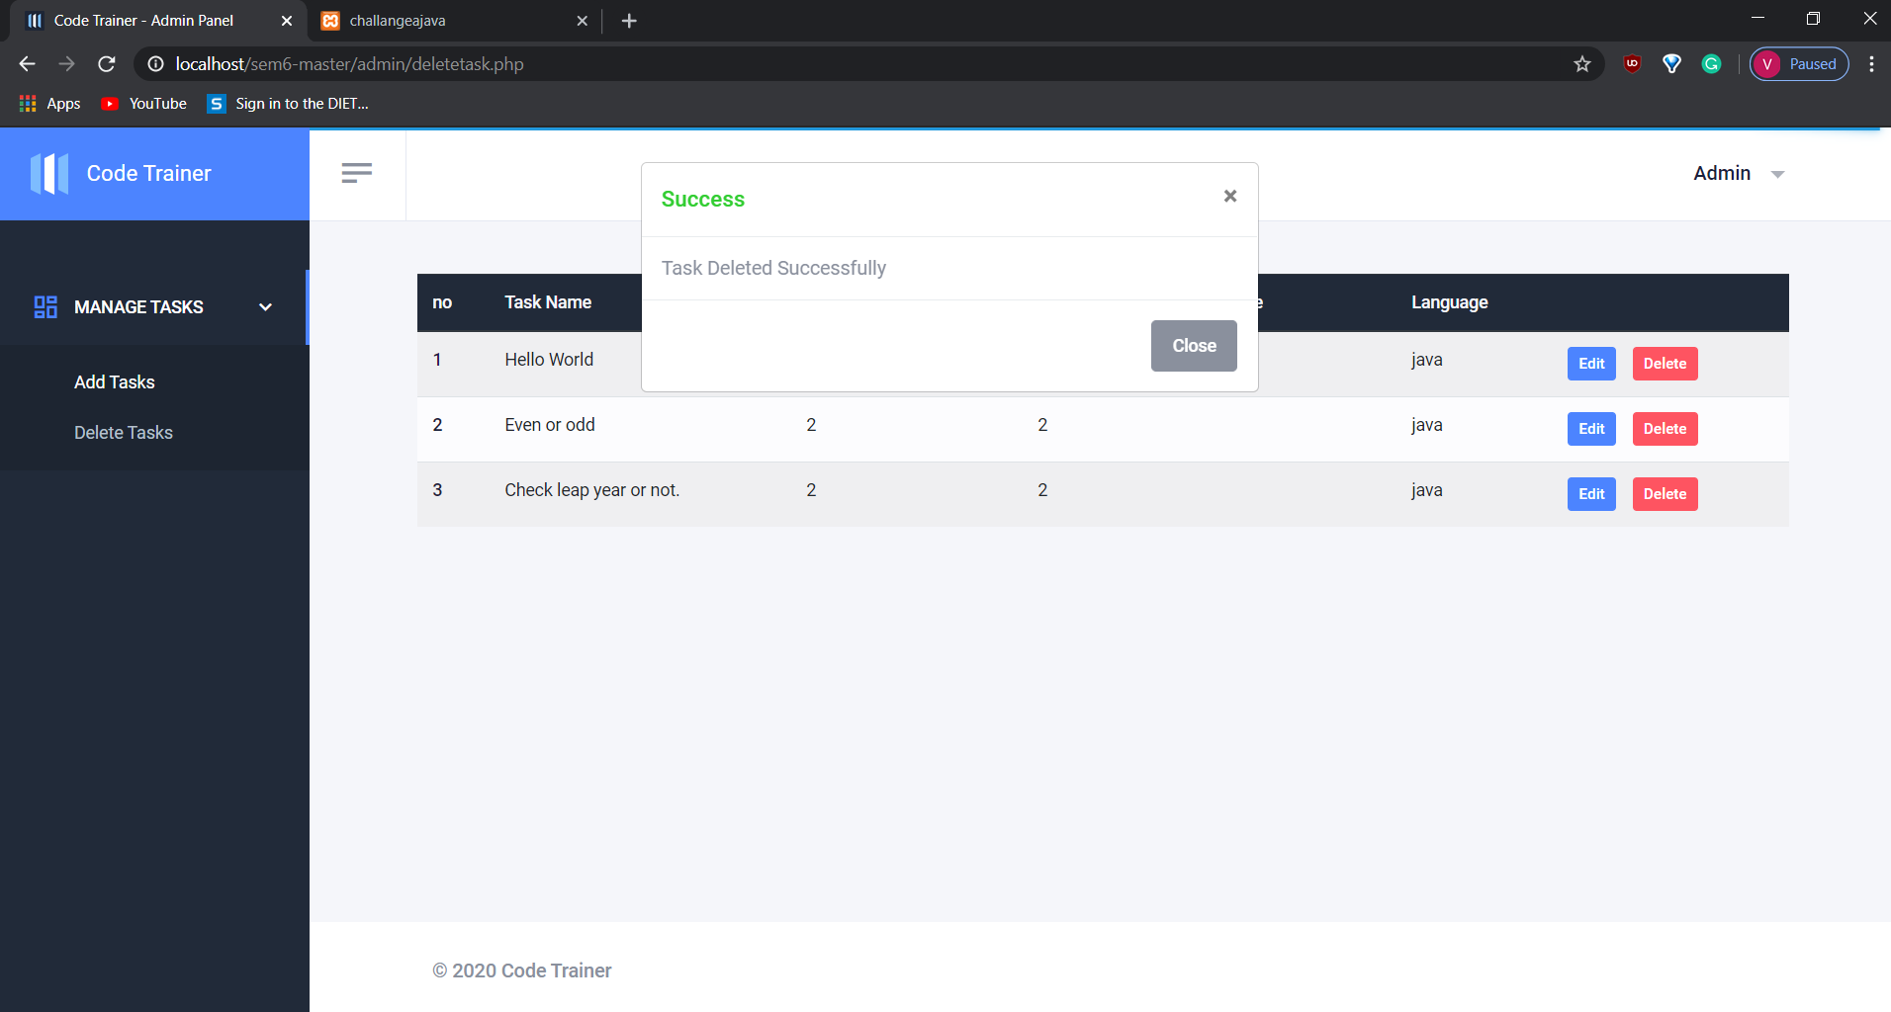

Fig:-1.3

* Fig 1.1 displays about adding tasks.
* Fig 1.2 displays about adding the data of task given.
* Fig 1.3 displays about deleting the tasks.

**6.11 Admin Page**

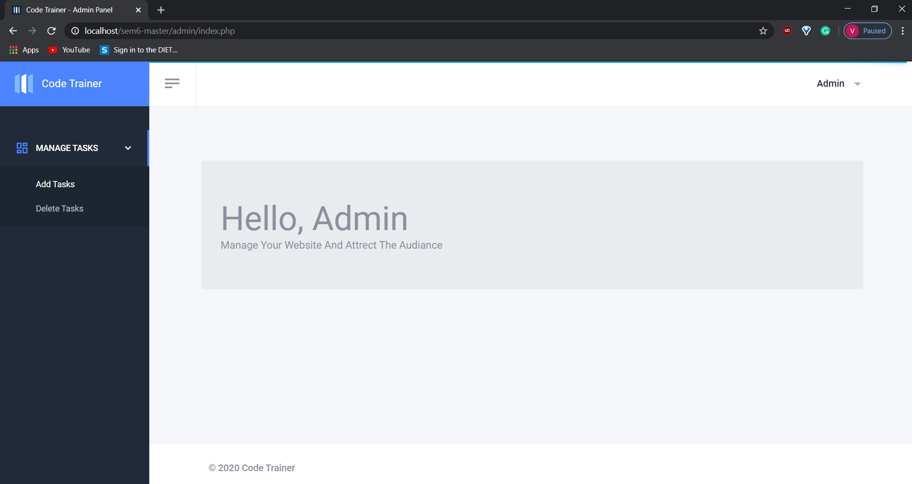

**Fig:-1.1**

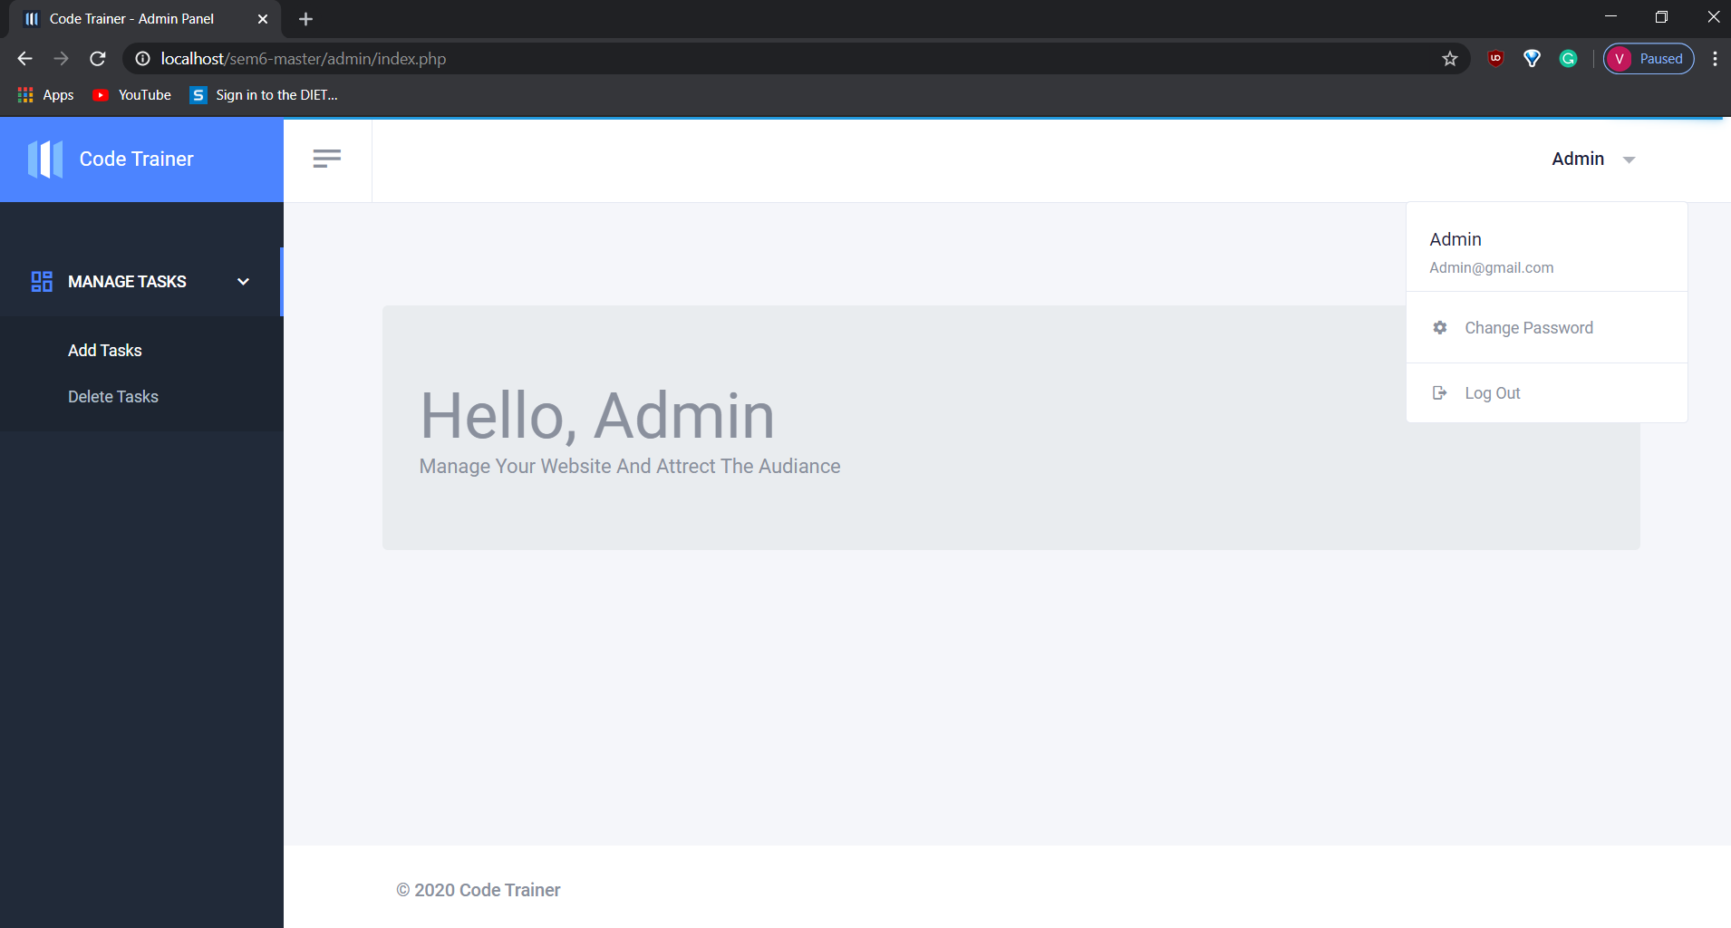

**Fig:-1.2**

* Main store page is displayed as above.
* Products are listed with price and with different available options.
* User can search products or filter by category.

**6.12 Sign In Page for Admin**

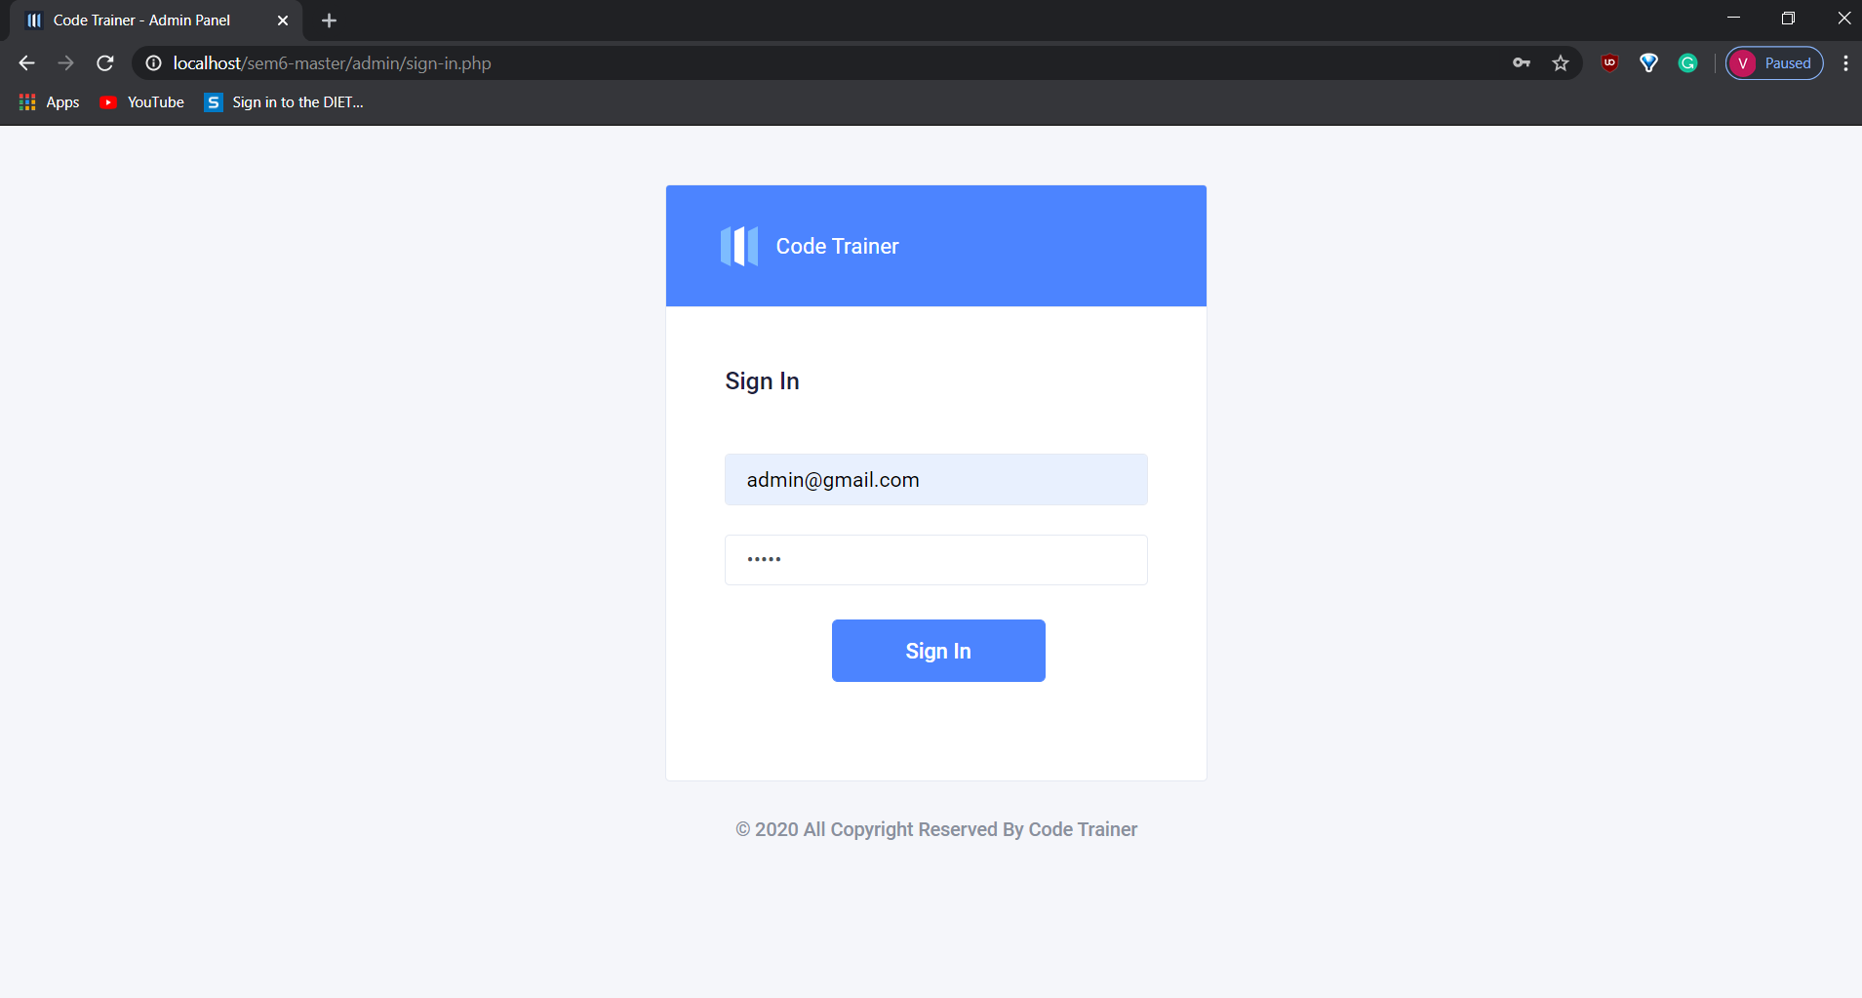

* In this page admin has to fill all the details given.
* Admin account will be created.

**6.13 Password Change Page for Admin**



* This page specifies to change the password in any condition.
* If user forgets or has to create new password then this page is loaded.

**6.14 About Us Page**

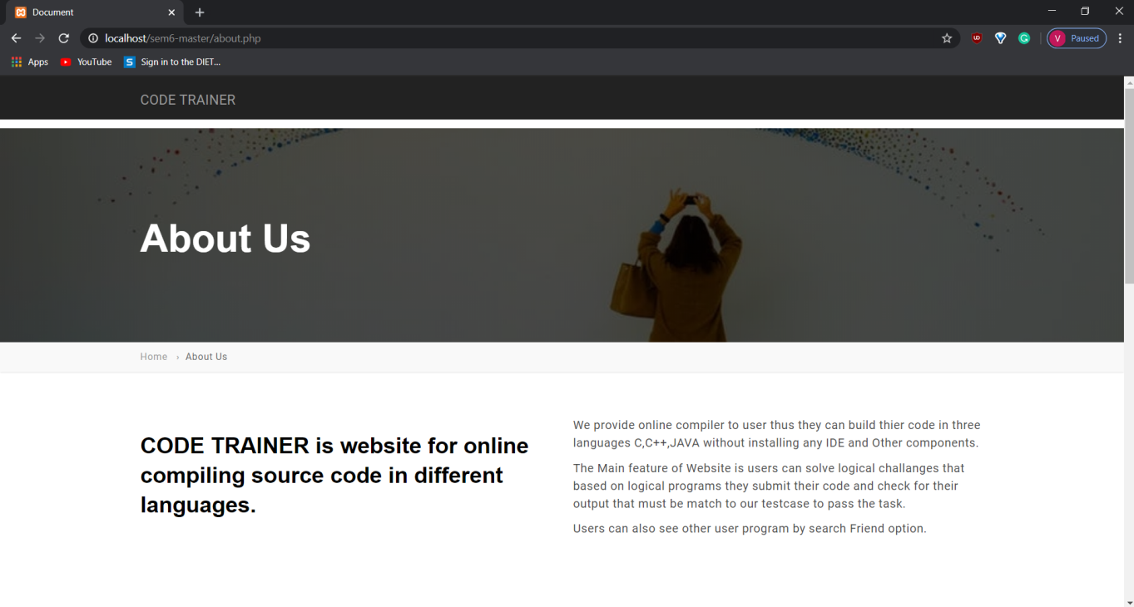

**Fig:-1.1**

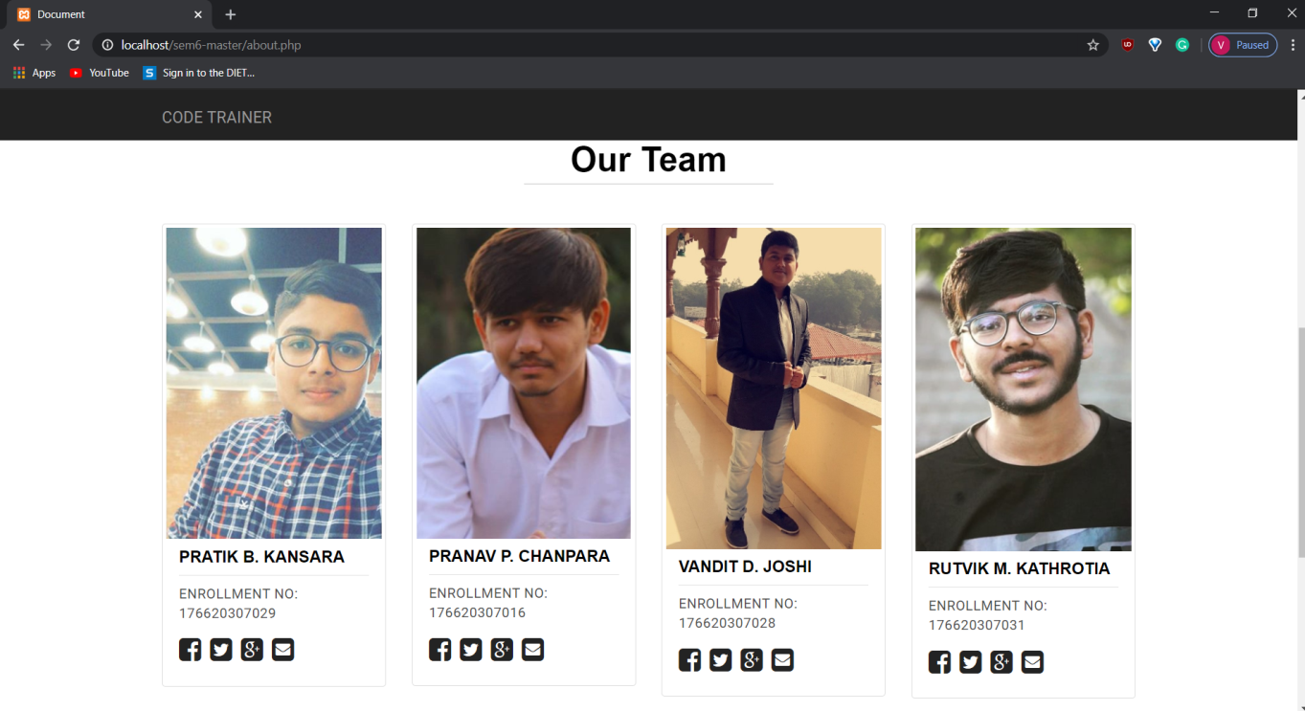

**Fig:-1.2**

* Fig 1.1 displays the information about this website.
* Fig 1.2 displays the information about the creators of this website

**Future Enhancement**

We will add many more languages and make**the editor** more interactive. We will also make interface of this website user friendly . We are also thinking to add healthy competition of**problem-solving** that improves the logic of programmers.

**8. EXPECTED OUTCOME**

Users will be able to code on our website in different languages like java,c,c++ without installing any component. And user also practice of code and solve different challenges provided by admin.